Step 1 Create a VCN

* Go to oci console and then click on hem-burger menu and select the networking Then click on Virtual Cloud Networks

Step 2

* We are now creating a new VCN manually
* click on Create VCN and you will get a new screen and then it will ask the required details like VCN name, IPV4 CIDR Block etc.

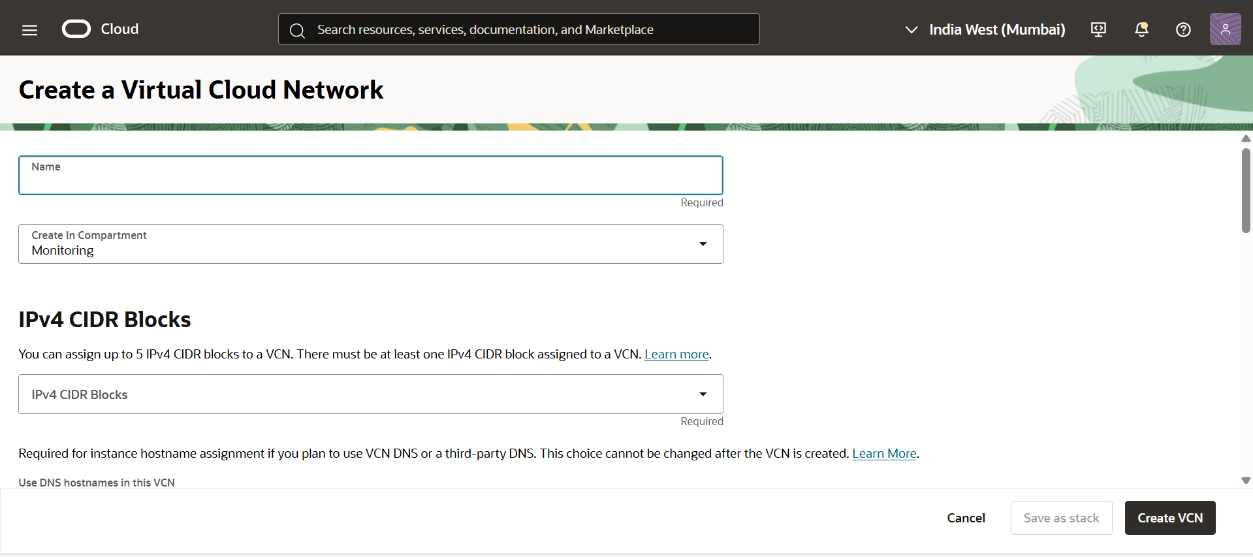

Step 3

* After creating VCN Go to VCN and Go to Subnet Option
* We have to create 2 subnets (Public, Private)
* First, we create a public subnet

* After creating Public Subnet, we go for Private Subnet, and we also have to create the private S.L for Private Subnet

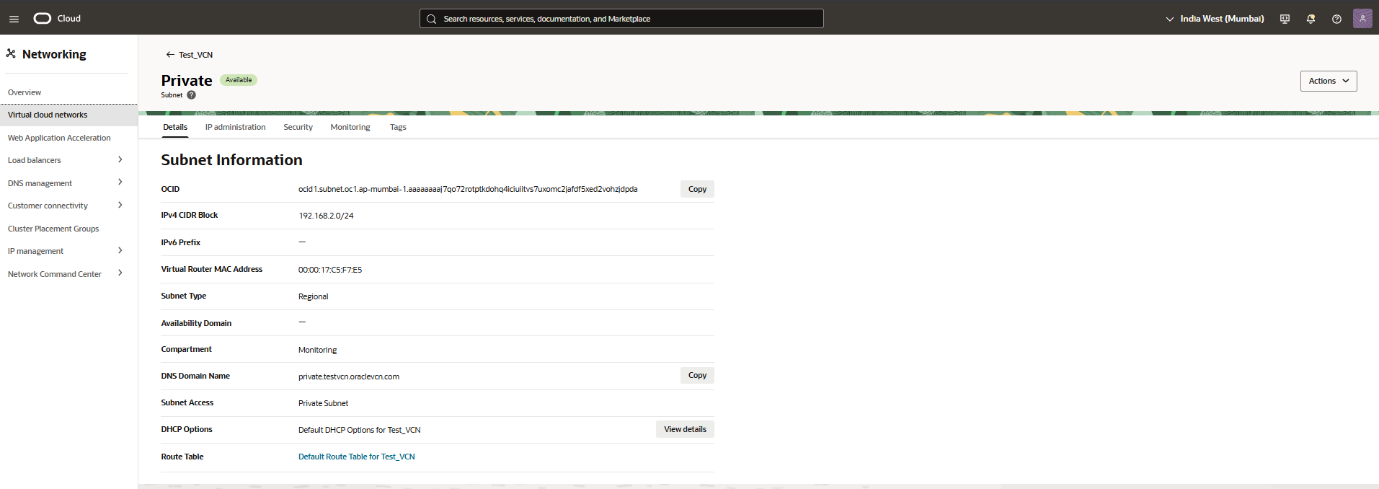

* Then we go for gateways we know that without Internet Gateway we cannot access the internet so first of all we create the internet gateway

* And we also create the NAT Gateway for private instance can access the internet

Step 4 Create Instances

* We have to create 2 instances for 1st for .docx file and 2nd for .info file and both are public instance
* Now we create 1st instance and upload the docx file in it

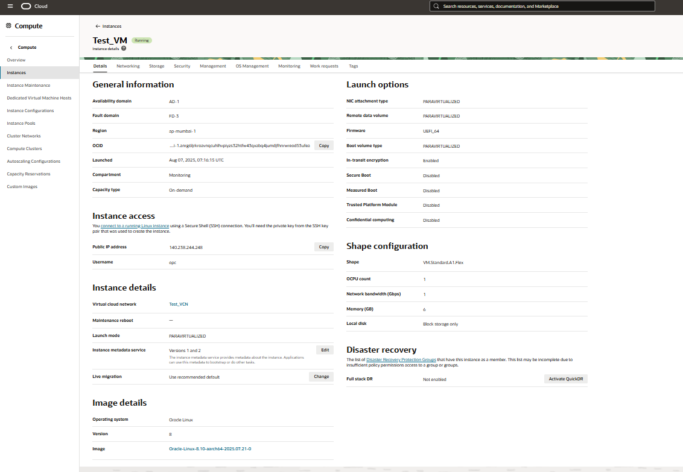

* Now when we complete the instance creation we can go for Apache server installation

* With this command we installed the Apache server, and paste the docx file in /var/www/html
* And add the 80 port in firewall so firewall cannot block the hosting with this command (Sudo firewall-cmd --permanent --add-port=80/tcp)
* Then try to curl it (curl <http://Instance_ip/--.docx>)
* Same things go to Instance 2, but we have to change only file in 2nd instance we have to add the .info file in /var/www/html

Step 5 Create a Load balancer

* In this step we create the load balancer and configure it

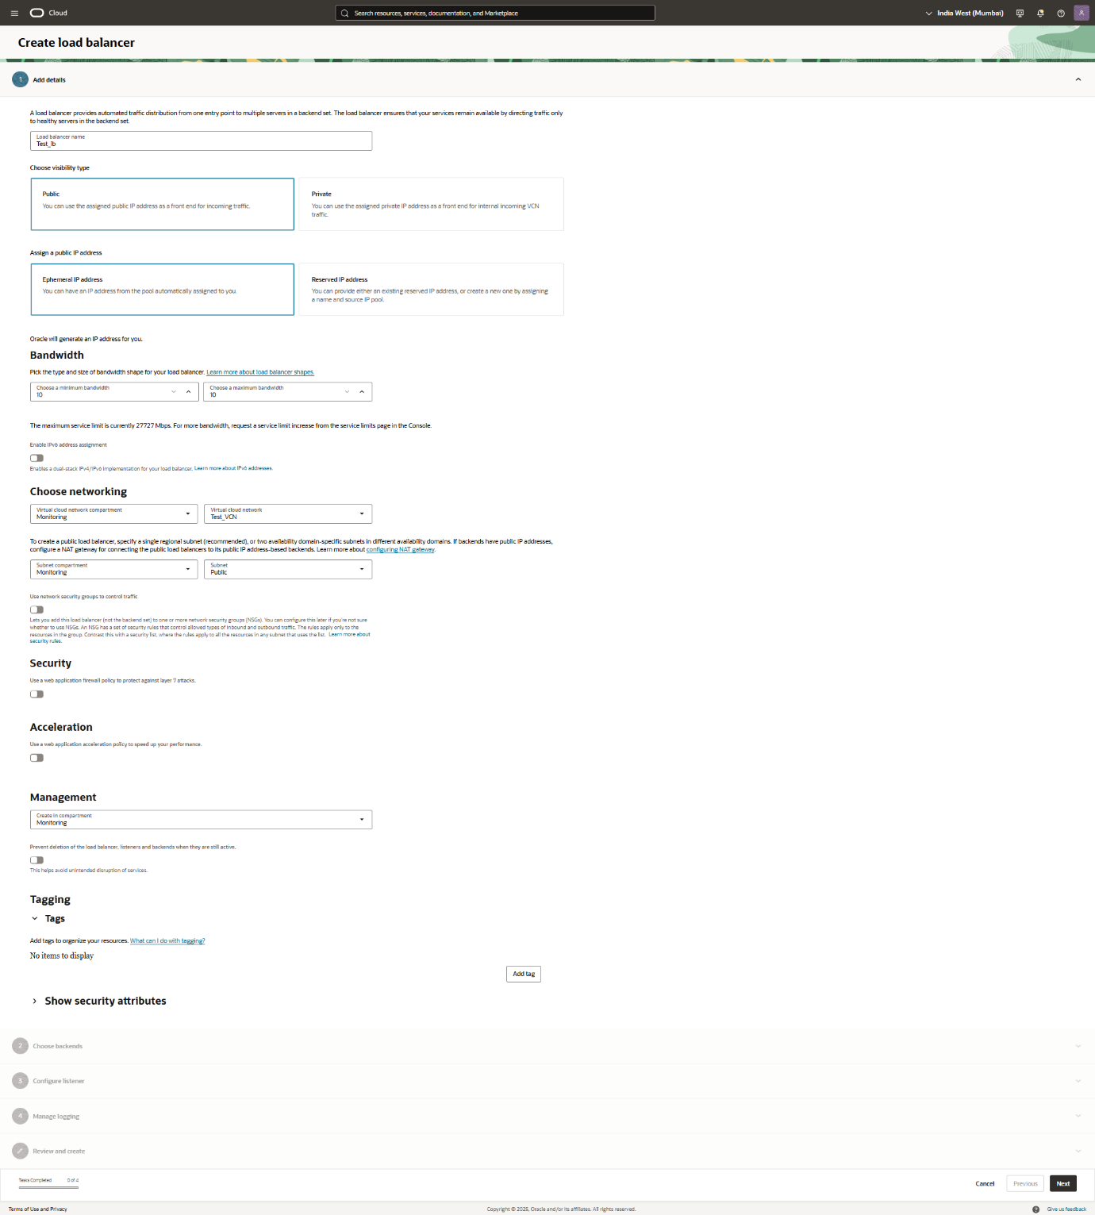

* In this lb creation process we have to choose Ip wherever it’s ephemeral or reserved in our case we choose ephemeral so Ip can automatically assign.
* In second phase we have to choose the backend sets and we need to specify the health policy

* In third phase we have to configure the listeners to **http port 80**

* Then start phase 4 logging in this phase we have to start the logs like error logs and access logs, so we have to enable it like you see in below screenshot

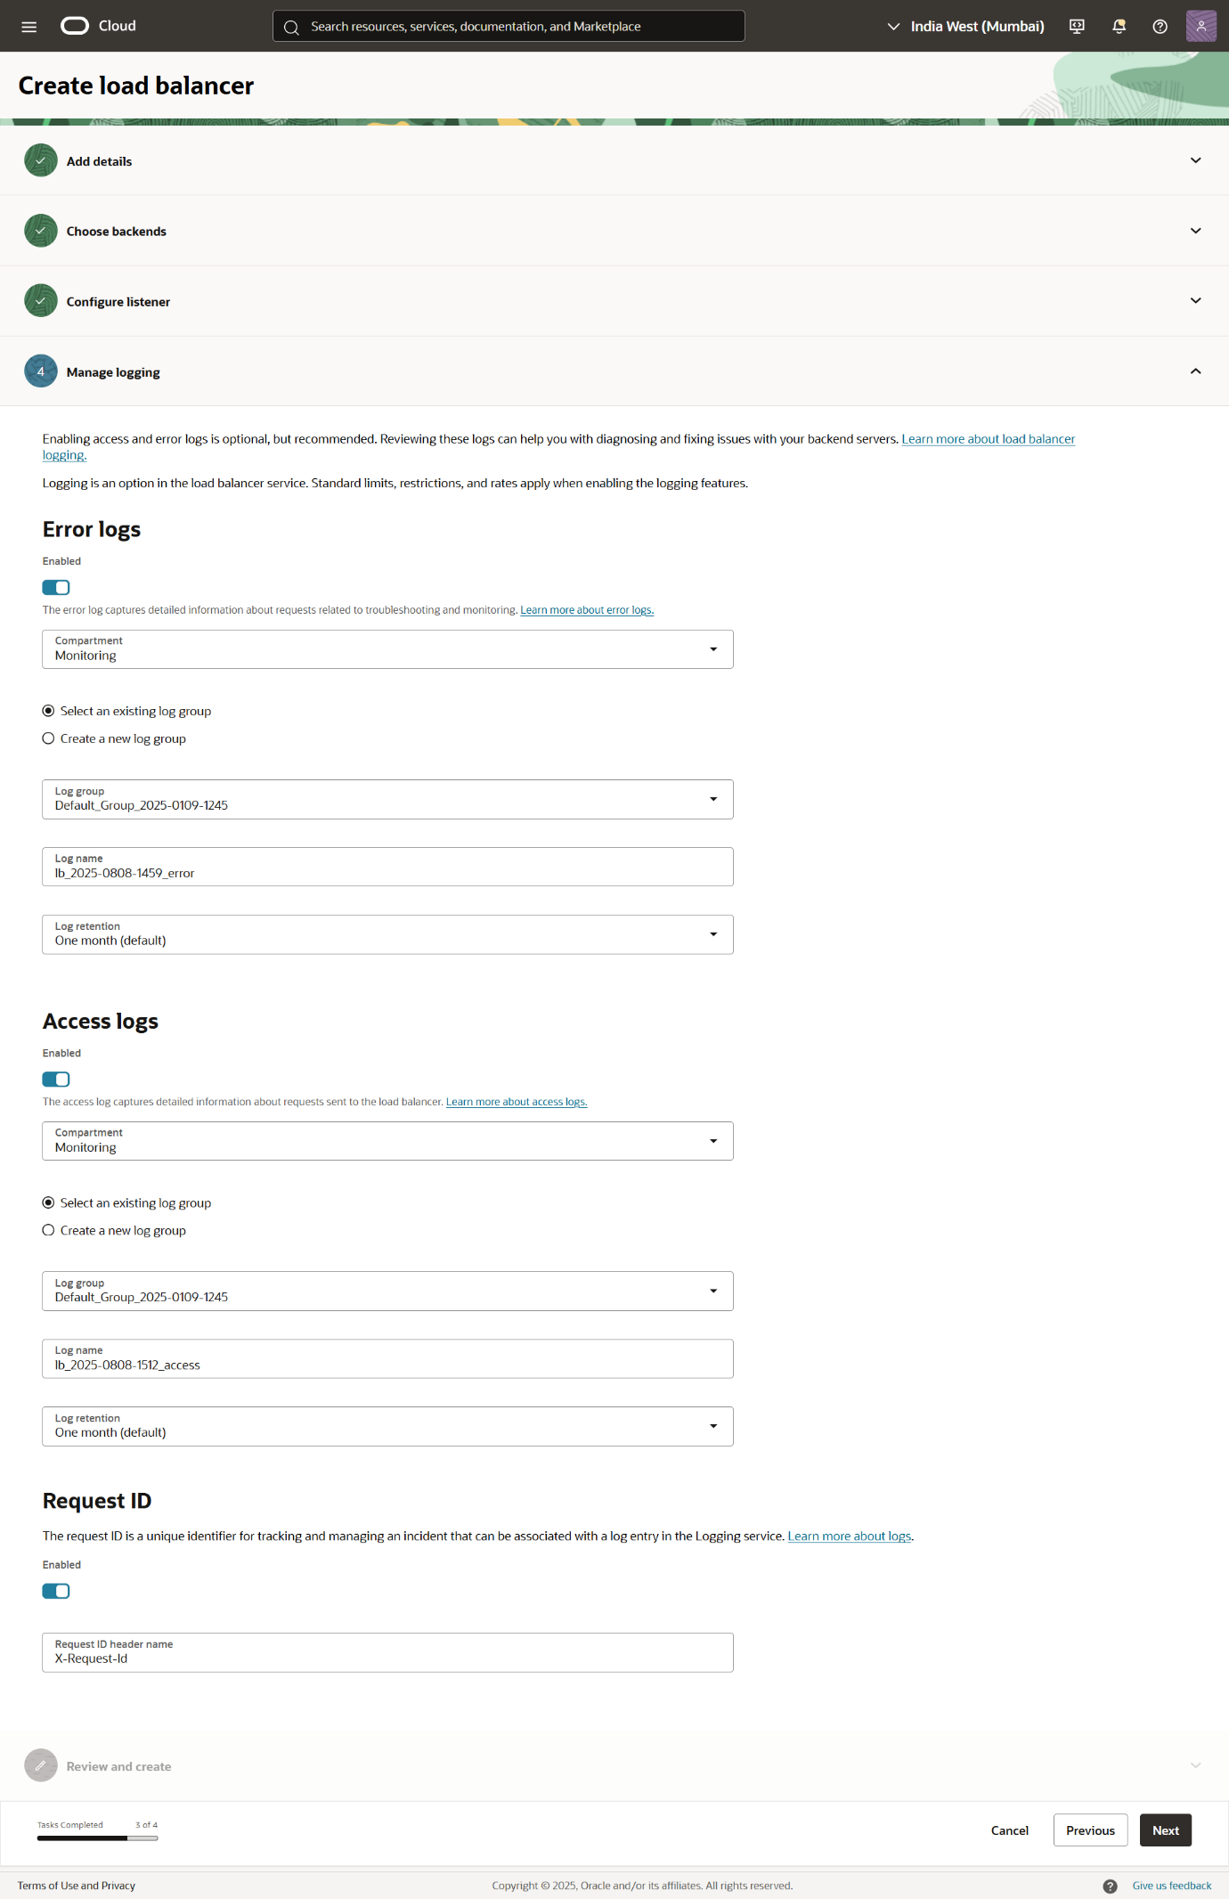

* Last step is to review all the things

* After creating the load balancer, we have to add the port 80 in the VCN’s Security list

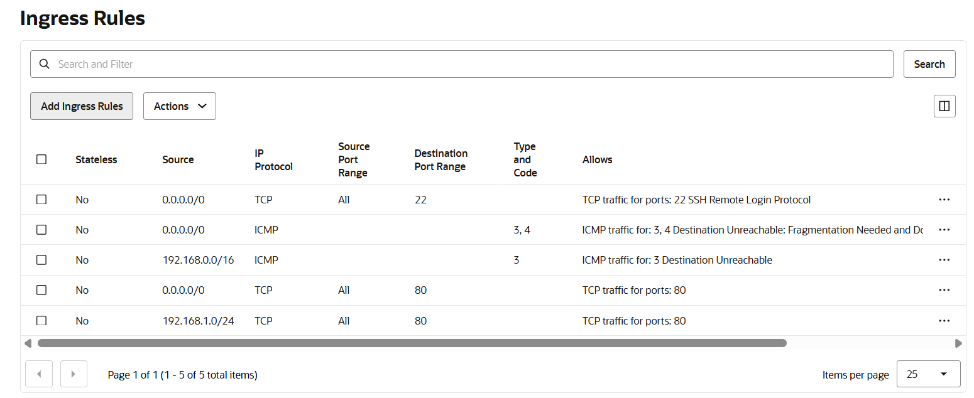

* Then we go to the Instance where we hosted our website and there, we add the port 80 to the firewall so the firewall couldn’t block out hosted website and we have to do it in both instance

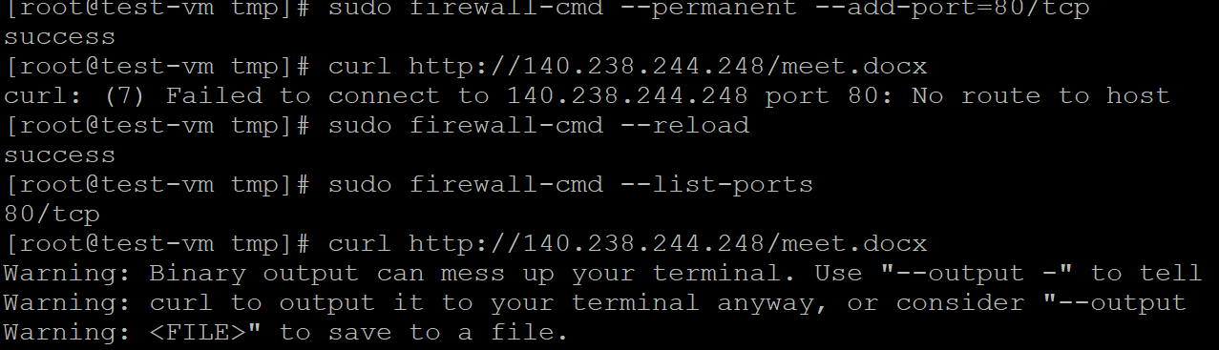

* Then we go to the oci console and go to load balancer and in load balancer we have to create a routing policy so the load balancer can manage the traffic form 2 different instances.

* We have to create a routing policy so the load balancer can divide the traffic in 2 different instances.

* This is rule 1 for instance 1

* This is rule 2 for instance 2
* After creating this rule, we have to add this rule in listener

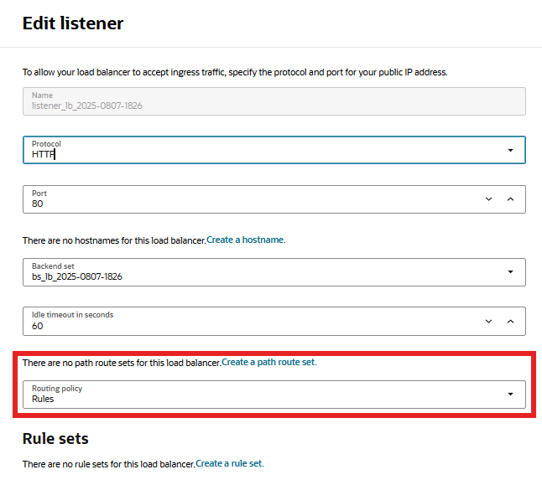

* Now after done this step, we completed the load balancer configuration and now its time to check the
* We have to go to the browser and in address bar we have to paste the load balancer public Ip and your file name like we add the .docx file in 1st instance and .data file in 2nd instance so first we hit the .docx file and there is an catch because the .docx file is not open in web browser so it can only download and if you want to watch it so you have o convert it in to .html format and I did both for 1st instance so if we want to watch the file we just have to paste the instance public Ip and then index.html the file name so we can see the file and if we have to download the file we have to change the file name like meet.docx like I mention below.

<http://loadbalancer_public_ip/filename>